**The Domino:**

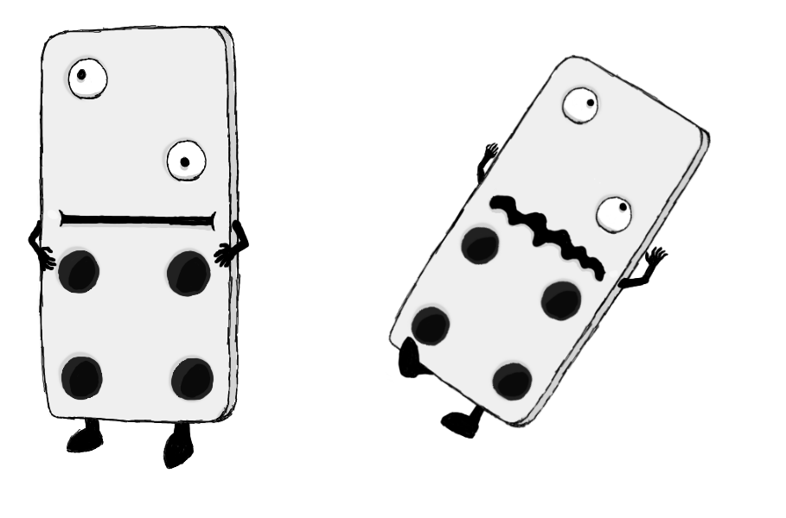

Figure 1 - Enemy: Domino

**Brief Synopsis**

The domino is a tall, bulky enemy. If attacked from the ground using weapons like the sword or the scythe it will take several hits to kill. However, upon hitting it using an aerial attack or the Shield charge, this enemy will lose balance and topple over, dying instantly. The Domino acts more like an obstacle than an enemy, and as such, has no attacks. If needed they could shuffle slowly side to side to block a player’s movement.

**Variants**

There are no distinct variants of the domino except for colour, for instance having a black and white Domino rather than a white and black one, as well as changing the numbers shown on the Domino itself. However, unless changed in the future, something like this would not affect the enemy’s behaviour and would be purely cosmetic.

**AI**

There is only very basic path finding for this enemy- it is given a region to guard and it will move sideways within this region to block the players movements.

**Animations**

The Domino will have three states: idle, shuffling and death.

**Idle:**

* The domino will stand stationary, occasionally moving its eyes and shuffling a little.

**Shuffling:**

* It will wobble slightly using its legs and move to the side.

**Death:**

* It will fall onto its back and then fade out.

**Average Size**

